Lahore Garrison University
DHA Phase 6 Lahore



Student Name | Shahzaib Ahmad
Student Roll No | Fa-2023-BSCS-703
Section | D
Subject | Web Technology
Instructor Name | Sir Muhammad Yousaf

Lab Task No. 07

🛠️ Lab 7: Responsive Design with Flexbox & Bootstrap Guide
This lab requires you to upgrade a static HTML layout into a modern, responsive design using three powerful tools: Flexbox, Media Queries, and Bootstrap.

Task 1: Convert a Static Layout to a Flexbox Layout
You will apply display: flex; to the main container to manage the positioning of the header, content, sidebar, and footer.

Conceptual HTML Structure
HTML
<body>
<header>...</header>
<div class="main-container">
<main class="content">...</main>
<aside class="sidebar">...</aside>
</div>
<footer>...</footer>
</body>

Key Flexbox CSS
- Define the Main Layout: Apply Flexbox to the container holding the main sections (content and sidebar).
CSS
.main-container {
display: flex; /* Activates Flexbox on this container */
width: 100%;
max-width: 1200px; /* Optional: Sets a max width for desktop screens */
margin: 0 auto; /* Centers the container */
}
.content {
flex: 3; /* Content takes 3 parts of the available space */
padding: 20px;
}
.sidebar {
flex: 1; /* Sidebar takes 1 part of the available space (3:1 ratio) */
padding: 20px;
background-color: #f4f4f4;
}

Task 2: Add Media Queries to Adjust Layout
The Flexbox layout above works great on a desktop. Now, you need Media Queries to stack the elements vertically for smaller screens (mobile/tablet).

Key Media Query CSS
You will target screens smaller than a tablet size (e.g., < 768px). On these smaller screens, you override the desktop Flexbox settings.
CSS
/* ---------------------------------- */
/* DEFAULT: Desktop/Tablet Flexbox Layout (from Task 1) */
/* ---------------------------------- */
.main-container {
display: flex;
/* ... other desktop styles ... */
}

/* ---------------------------------- */
/* MOBILE STYLES: Screens smaller than 768px */
/* ---------------------------------- */
@media (max-width: 768px) {
/* 1. Change the Flex direction to stack items */
.main-container {
flex-direction: column;
}

/* 2. Remove the flex ratio so content/sidebar take full width */
.content,
.sidebar {
flex: none; /* or flex: 0 0 100%; */
width: 100%;
}

/* Optional: Move the sidebar below the main content on mobile */
.sidebar {
order: 1; /* Pushes the sidebar down */
}
.content {
order: 2; /* Keeps the main content up */
}
}
- Deliverable Requirement: Ensure you take screenshots of the desktop, tablet, and mobile views to demonstrate that the layout successfully adjusts at the breakpoints defined by your media queries.

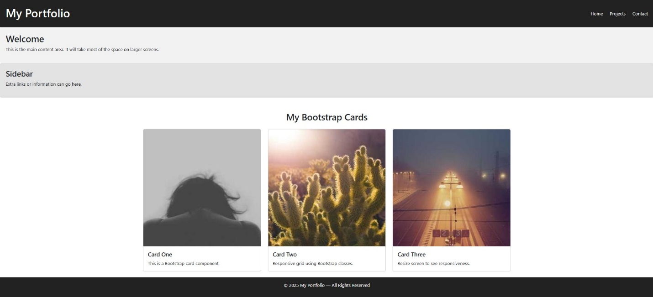

Task 3: Recreate a Component Using Bootstrap Classes
You will integrate the Bootstrap CDN and then use its utility classes to quickly style a component, like a navigation bar or a grid of portfolio cards.

A. Set up Bootstrap
Add these lines to the <head> section of your HTML file:
HTML
<link href="https://cdn.jsdelivr.net/npm/bootstrap@5.3.3/dist/css/bootstrap.min.css"
rel="stylesheet"
integrity="sha384-QWTKZyjpPEjISv5WaRU9OFeRpok6YctnYmDr5pNlyT2bRjXh0JMhjY6hW+ALEwIH"
crossorigin="anonymous">

<script src="https://cdn.jsdelivr.net/npm/bootstrap@5.3.3/dist/js/bootstrap.bundle.min.js"
integrity="sha384-YvpcrYf0tY3lHB60NNkmXc5s9fDVZLESaAA55NDzOxhy9GkcIdslK1eN7N6jIeHz"
crossorigin="anonymous"></script>

B. Example: Bootstrap Card Grid¹
Bootstrap's Grid Syst²em is built on Flexbox, making it excellent for creating responsive card layouts with minimal effort.
HTML
<section class="container my-5">
<h2 class="text-center mb-4">Portfolio Projects</h2>

<div class="row row-cols-1 row-cols-md-3 g-4">

<div class="col">
<div class="card h-100">
<div class="card-body">
<h5 class="card-title">Project Alpha</h5>
<p class="card-text">A brief description of project alpha and its technologies.</p>
<a href="#" class="btn btn-primary">View Project</a>
</div>
</div>
</div>

<div class="col">
<div class="card h-100">
<div class="card-body">
<h5 class="card-title">Project Beta</h5>
<p class="card-text">A brief description of project beta and its technologies.</p>
<a href="#" class="btn btn-primary">View Project</a>
</div>
</div>
</div>

</div>
</section>
Bootstrap Class | Purpose
.container | Provides centered, padded content area.
.my-5 | Adds margin on the Y-axis (top/bottom) for spacing.
.row | Defines a row in the Bootstrap grid.
.row-cols-1 | Mobile: Shows 1 card per row.
.row-cols-md-3 | Medium/Desktop: Shows 3 cards per row.
.g-4 | Sets the gutter (spacing) between the columns/cards.
.card | Basic Bootstrap component for a styled box.

CONCLUSION:
In this lab, I made a static layout responsive using Flexbox, media queries, and Bootstrap. Flexbox helped structure the page, media queries made it adjust on different screen sizes, and Bootstrap added an easy responsive component. Overall, the layout now works smoothly on mobile, tablet, and desktop.
RUBRICS:

Performance |  |  | Lab Report
Description | Total Marks | Marks Obtained | Description | Total Marks | Marks  Obtained
Ability to Conduct practical | 5 |  | Structure | 5
Data Analysis & Interpretation | 5 |  | Efficiency | 5
Total Marks obtained |  |  | Total Marks Obtained

Instructor Signature

